Bahria University,

Karachi Campus



LAB EXPERIMENT NO.

**03**

LIST OF TASKS

|  |  |
| --- | --- |
| TASK NO | OBJECTIVE |
| 1 | **Login Page Application using Relative Layout.** |
| 2 | **Calculator Application using both Relative and Constraint Layout.** |
| 3 | **Food Ordering Application using Constraint Layout.** |

Task 1: **Login Page Application using Relative Layout.**

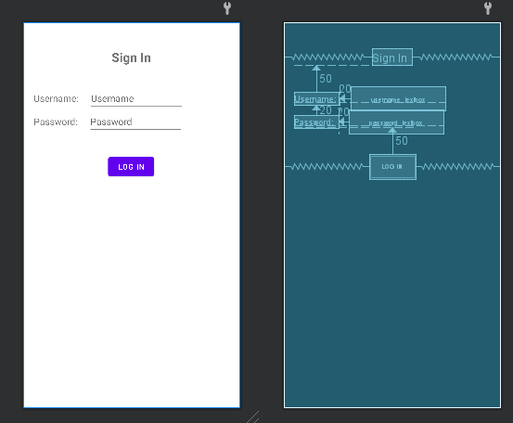

Task 2: **Calculator Application using both Relative and Constraint Layout.**

Task 3: **Food Ordering Application using Constraint Layout.**



